# **Railway, sign, train iconTRAINVAGO**

# *Railway Administration System*



# Project participants

* **Name**: Atanas Burmov

*Email*: [AABurmov18@codingburgas.bg](mailto:AABurmov18@codingburgas.bg)

* **Name**: Dani Dimov

*Email*: [DSDimov18@codingburgas.bg](mailto:DSDimov18@codingburgas.bg)

* **Name**: Kristian Milanov

*Email*: [KAMilnaov18@codingburgas.bg](mailto:KAMilnaov18@codingburgas.bg)

* **Name**: Kristian Lalev

*Email*: [KALalev18@codingburgas.bg](mailto:KALalev18@codingburgas.bg)

# Снимка на Петър Георгиев.Consultant

* **Name:** Petur Georgiev

*Email:* [PGergiev@codingburgas.bg](mailto:PGergiev@codingburgas.bg)

# Our Idea Trainvago

## The main idea of the project is to better and to automatize the administrative working processes of the current railway system. The following project presents benefits not only for the railway system but for its customers in a way that they will be able to navigate faster when using the railway services.



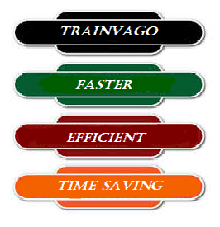

# Project system

## The main menu

### User has to choose one of the roles

## The main menu of the administrator

### First - the user must enter a password

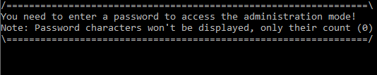

### If the password is correct, the system shows the administrator menu

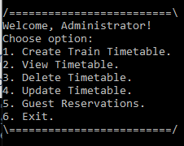

#### The administrator can choose whatever of the options, dependent on the following tasks.

## The main menu of the guest

### First - the user must enter a username

### When the user enters his name, the system is showing the guest menu

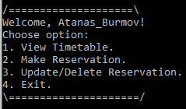

#### The guest can choose whatever of the following options.

#### When the guest chooses the option “View Timetable”, the TRAINVAGO website opens

# Diagram of our software

## Download in a better quality: <https://codingburgas-my.sharepoint.com/:f:/g/personal/kamilanov18_codingburgas_bg/Et5XqpTgTUdBrVhzzryc7-gBOqZrh31ixI_FHhVTvIj5CQ?e=A1ibCM>

# Description of the commonly used function

|  |  |  |  |  |  |
| --- | --- | --- | --- | --- | --- |
|  | CreateTimetable | DisplayTimetable | loadData | readInt | WriteHTML |
| Arguments | TRAIN* trains, int& count, int& maxId, TRAIN newData | TRAIN* trains, int count | TRAIN* trains, int count | (0) | TRAIN* trains, int count |
| Meaning | Helps with creating a new timetable for the trains. | Helps display all data in the trains array. | Loads data from a file in the trains array. | Prompts the user for input endlessly, if it is invalid. | Transfer the data from trains array into web.HTML. |
| Return value | Void | Void | Void | Int | Void |